Question 1

In Homework #1, you were tasked to design a relational database schema for a university database used to keep track of students’ transcripts. In this assignment, you will take the corresponding database design and implement it using SQLite. If you are not yet already proficient with SQL, it is imperative that you acquire and familiarize yourself with it promptly, as it is essential for completing this and future assignments.

Task 1: Implement the Schema [35 Pts.]

1. Based on the relational schema provided below in Figure 1, write the SQL state ments to create all necessary tables in an SQLite database. Make sure that your tables accurately reflect the entities, attributes, and relationships you defined. You may assume the following: [15 points]

• Both Ssn and Snum are unique for each student.

• Each student is allowed to have exactly one current address, one permanent address, one current phone number, and one permanent phone number.

• Students enrolled in a particular degree program can have multiple majors and minors.

• A student can be in two different degree programs.

• Both Dname and Dcode have unique values for each department.

• Each department can be associated with multiple colleges.

• Both Cnum and Cname are unique for each course.

• Each course can be offered by multiple departments, reflecting the interdisci plinary nature of some programs.

• The section number (Snum) differentiates various sections of the same course taught in the same semester/year.

2. Your table creations must also include SQL constraints to enforce primary keys, unique keys, foreign keys, and any other critical constraints that you deemed im portant such as NOT NULL, domain constraints (e.g., data types, range values), and any other predicate-based constraints (e.g., CHECK constraints ensuring specific con ditions are met). [10 points]

3. Populate each table in your database with at least 3 entries that are representative and appropriate, adhering to the integrity constraints of the database. [10 points]

Task 2: Data Redundancy and Anomalies [30 Pts.]

1. Define at least one SQL data insertion query that would demonstrate an insertion anomaly relevant to data redundancy. Your answer should include the correct SQL insertion query and a strong explanation of the scenario that leads to the anomaly and why this anomaly is undesirable. [10 points]

Page 2

HW #3 Database Systems 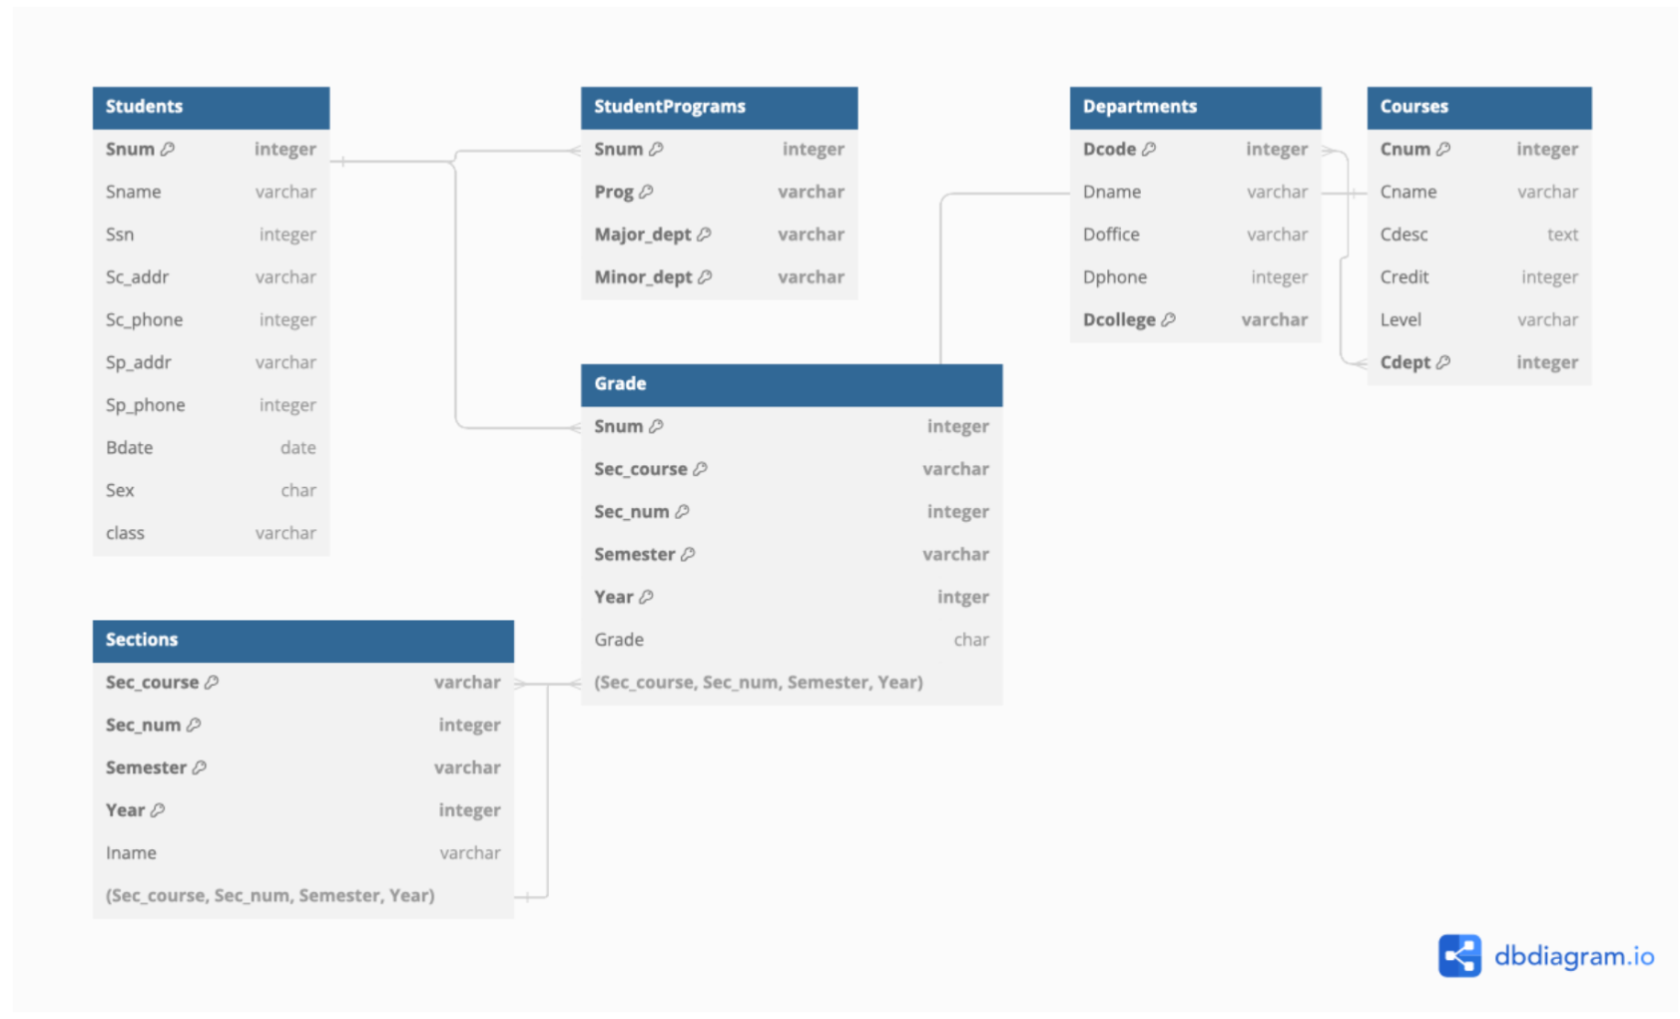Figure 1: HW #1 Relational Database Schema

2. Define at least one SQL data modification query that would demonstrate a mod ification anomaly relevant to data redundancy. Your answer should include the correct SQL modification query and a strong explanation of the scenario that leads to the anomaly and why this anomaly is undesirable. [10 points]

3. Define at least one SQL data deletion query that would demonstrate a deletion anomaly relevant to data redundancy. Your answer should include the correct SQL deletion query and a strong explanation of the scenario that leads to the anomaly and why this anomaly is undesirable. [10 points]

Task 3: Normalizing Relations to the Highest Normal Form [20 Pts.]

1. For EACH relation given in the schema, normalize it to the highest normal form possible (from 1NF up to 4NF). Do not worry about 5NF or DKNF. Given below is the list of functional dependencies applicable to each relation that could be utilized to guide your normalization process:

Students Relation

Primary Key: *{*Snum*}* Unique Keys: *{*Ssn*}*

StudentPrograms Relation

Primary Key: *{*Snum, Prog, Major dept, Minor dept*}*

Departments Relation

Page 3

HW #3 Database Systems

Primary Key: *{*Dcode, Dcollege*}* Unique Keys: *{*Dname, Dcollege*}* FDs:

Dcode *→ {*Dname, Doffice, Dphone*}*

Dname *→ {*Dcode, Doffice, Dphone*}*

Courses Relation

Primary Key: *{*Cnum, Cdept*}* Unique Keys: *{*Cname, Cdept*}*

FDs:

Cnum *→ {*Cname, Cdesc, Credit, Level*}*

Cname *→ {*Cnum, Cdesc, Credit, Level*}*

Sections Relation

Primary Key: *{*Sec course, Sec num, Semester, Year*}*

Grade Relation

Primary Key: *{*Snum, Sec course, Sec num, Semester, Year*}*

2. For each decomposition step, state the reasons behind the decomposition. 3. Your answer should include the following for each relation:

• Initial form (e.g., 1NF) with an explanation based on the given functional dependencies.

• Decomposition step to the next normal form (e.g., 2NF) with reasons. • Continue this process up to 4NF.

Question 2 [15 Pts.]

Examine your solutions in Question 1, if no relation exhibits a violation for a particular normal form (1NF to 4NF), create a new table (or modify an existing one) based on the existing schema that demonstrates the violation.

1. If a normal form has been violated and then normalized in Question 1, skip this particular normal form.

2. If every normal form has been violated and normalized in Question 1, leave this question blank.

3. If you are able to identify or create a violation for 5NF or DKNF and normalize it, you may be awarded extra credit (5 points each).

Page 4